**Intergtaion of Multi-Frquency Ensemble Machine Learning Models Towards Crude Oil Price Forecasting**

Farid Javadnejad, Ph.D.*

Geospatial Engineering Consultant, Aerogeospatial LLC, 1401 21st Street, Suite R, Sacramento, CA 95811, e-mail: *nejad.fj@gmail.com*.

# Introduction

Crude oil and other refined liquid products from fossil fuels are critical contributors to the world economy. Petroleum has been the largest [energy source](https://www.eia.gov/energyexplained/us-energy-facts/) for all countries. Its products run vehicles, heat buildings, and produce electricity. Moreover, various industries use petroleum as a raw material to produce intermediate or end-user products that we use daily (EIA 2022b; Lu et al. 2021; Deng, Ma, and Zeng 2021; Kilian and Murphy 2014). In 2019, global petroleum consumption neared 100 million barrels per day (Table 1).

Table . The largest oil consumers and their share of total world consumption (EIA 2022b)

|  |  |  |  |
| --- | --- | --- | --- |
| Ranking | Country | Million barrels per day | Share of world total |
| 1 | United States | 20.54 | 20% |
| 2 | China | 14.01 | 14% |
| 3 | India | 4.92 | 5% |
| 4 | Japan | 3.74 | 4% |
| 5 | Russia | 3.70 | 4% |
| 6 | Saudi Arabia | 3.18 | 3% |
| 7 | Brazil | 3.14 | 3% |
| 8 | Canada | 2.63 | 3% |
| 9 | South Korea | 2.60 | 3% |
| 10 | Germany | 2.35 | 2% |
|  | World total | 100.23 |  |

## Problem statement

Crude oil prices are difficult to predict accurately due to the number of influencing factors and the highly complex behavior of such influences. Global economic and social activities can be substantially impacted by fluctuations in crude oil prices. Threfore, despite challenges for prediction of oil price, accurate oil price forecasting is crucial for decision-making support for the manufacturing, logistics, and government sectors to guide industrial and social policies and practices (Kilian and Murphy 2014; Deng, Ma, and Zeng 2021; Lu et al. 2021).

## Background

Brent, West Texas Intermediate (WTI), Dubai/Oman, and Shanghai crude oil prices are the major benchmarks of the crude oil market and are reported is USD per barrel unit. Factors such as supply and demand, financial markets and economics, politics, global events, renewable energy and alternative resources, new resources and development of new oil extraction technologies, social & environmental policies, and consumption patterns may influence the crude oil market dynamics. Such impacts and resultant price fluctuations might be very complex and may occur at different frequencies.

Classical econometric models such as random walk, autoregressive integrated moving average (ARIMA), error correction model (ECM), generalized autoregressive conditional heteroscedasticity (GARCH) model are used for crude oil price prediction. Recently, machine learning (ML) methods such as artificial neural network (ANN) and support vector machine (SVM) are used for the crude oil price prediction, which provide powerful tools to model nonlinear behavior or crude oil market dynamics (Jammazi and Aloui 2012; Lanza, Manera, and Giovannini 2005; Hou and Suardi 2012; Basiri 2015; Yu, Zhao, and Tang 2017; Murat and Tokat 2009; Kilian and Murphy 2014; Javadnejad 2012).

## Objectives

In this work, an ML model is proposed to predict crude oil price using multiple infulencing factors. The predictions are casted on multiple time-series to consider for complex factors that imact the market dynamics in differenct frequencies.

This report is structured as follows. Section describes the metholdogy, where Sub-section 2.1 summarizes the datasets that are used in this study. Sub-section 2.2 describes the data preparation and data wrangling procedures. In Sub-section 2.3, the exploratory data analysis and feature engineering approcahes for ML training are described. Sub-section 2.4 covers the ML pre-processing, training, models selection, model metrics. In Sub-section 2.5, the final results for model training and validation are presented, as well as the predictions for 6-month time frequencies. We present the discussion of our results in Section 3. Finally, in Section 4, we summarise our recoomendaiton for future work.

# Methodology

## Datatets

The factors that influence the crude oil market dynamics include supply and demand, financial markets, politics, global events, alternative resources, development technologies, policies, and consumption patterns (Hamilton 2008; Hamilton 2009; Kilian and Murphy 2014; Zhao, Li, and Yu 2017; Lu et al. 2021; Wang, Wu, and Yang 2015). We use the crude oil prices of West Texas Intermediate (WTI) benchmark as the target feature. To take into account the aforementioned influencing factors a total of 32 feature variables were selected from publicly accessible data sources (EIA 2022a; FRED 2022; Investing 2022; WSJ 2022). Table 2 provides a list of the selected features, a description about each feature, and the sources of data.

Table . Selected dataset of feature variables for crude oil price

|  |  |  |  |  |
| --- | --- | --- | --- | --- |
| Category | Symbol | Variable | Unit | Source |
| Crude Oil Price | WTIPUUS | West Texas Intermediate Crude Oil Price | dollars per barrel | EIA |
| Supply | COPR_OPEC | Crude Oil Production, Total OPEC | million barrels per day | EIA |
|  | PAPR_NONOPEC | Crude Oil Production, Total non-OPEC | million barrels per day | EIA |
|  | INTL.55-1-WORL-TBPD | Crude Oil Production, NGPL, and other liquids production, World | thousand barrels per day | EIA |
|  | COPRPUS | Crude Oil Production, U.S. | million barrels per day | EIA |
| Replacement Cost | RNGWHHD | Henry Hub Natural Gas Spot Price | dollars per million btu | EIA |
| Demand | PATC_OECD | Liquid Fuels Consumption, Total OECD | million barrels per day | EIA |
|  | PATC_NON_OECD | Liquid Fuels Consumption, Total non-OECD, | million barrels per day | EIA |
|  | FEDFUNDS | Federal Funds Effective Rate | percent, not seasonally adjusted | FRED |
|  | IGREA | Index of Global Real Economic Activity | index, not seasonally adjusted | FRED |
|  | CICPIUS | US Consumer Price Index (CPI): All Commodities | index, 1982-1984=1.00 | EIA |
|  | USACPIENGMINMEI | US Consumer Price Index (CPI): Energy for the United States | index 2015=100, not seasonally adjusted | FRED |
|  | WPCPIUS | US Producer Price Index (PPI): All Commodities | index, 1982=1.00 | EIA |
|  | WP57IUS | US Producer Price Index (PPI): Petroleum | index, 1982=1.00 | EIA |
|  | EA19PIEAMI01GPM | roducer Price Index (PPI) of Euro Area (19 Countries) | index 2015=100, not seasonally adjusted | FRED |
|  | ZOMNIUS | US Manufacturing Production Index (PMI) | index, 2017=100 (seasonally adjusted) | EIA |
| Inventory | PASC_OECD_T3 | Petroleum Inventory, Total OECD | million barrels, end-of-period | EIA |
|  | PASXPUS | Petroleum Inventory, US Total | million barrels, end-of-period | EIA |
|  | COSQPUS | US Crude Oil Inventory: Strategic Petroleum Reserve (SPR) | million barrels, end-of-period | EIA |
|  | COSXPUS | US Crude Oil Inventory: Non-SPR | million barrels, end-of-period | EIA |
| Monetary Market | RTWEXBG | Real Broad Dollar Index | index Jan 2006=100, not seasonally adjusted | FRED |
|  | DXY | US Dollar Index (DXY) | index | Investing |
|  | DEXUSEU | U.S. Dollars to Euro Spot Exchange Rate (DEXUSEU) | US dollars to one euro, not seasonally adjusted | FRED |
| Stock Market | SPX | S&P 500 Index | index | WSJ |
|  | DJI | Dow Jones Industrial Index | index | WSJ |
|  | COMP | NASDAQ index | index | WSJ |
| Commodity Market | Gold_Future | Gold Futures Historical Data | dollar per ounce | Investing |
|  | Copper_Future | Copper Futures Historical Data | dollar per pound | Investing |
| Policy Uncertainty | GEPUCURRENT | Global Economic Policy Uncertainty Index: Current Price Adjusted GDP | index, not seasonally adjusted | FRED |
| Technology | MGWHUUS | Refiner Wholesale Gasoline Price | cents per gallon | EIA |
|  | DSWHUUS | Diesel Fuel Refiner Wholesale Price | cents per gallon | EIA |
|  | BREPUUS | Brent Crude Oil Spot Price | dollars per barrel | EIA |

## Data Cleaning and Data Wrangling

We used Jupyter Notebook 6.5.2 (Kluyver et al. 2016) and Python 3.9.15 (Python Software Foundation 2022) to process the data. The features in Table 2 were read through APIs (if available) or were downloaded directly from the data source. The data were initially set to be imported with monthly intervals or averaged to monthly values, then were limited to the target time frame of January 2000 and December 2022. The features were index based on their date values and then all merged together on the date values to create corresponding feature values for each month. Figure 1 shows the monthly West Texas Intermediate (WTI) crude oil price in the target time frame.

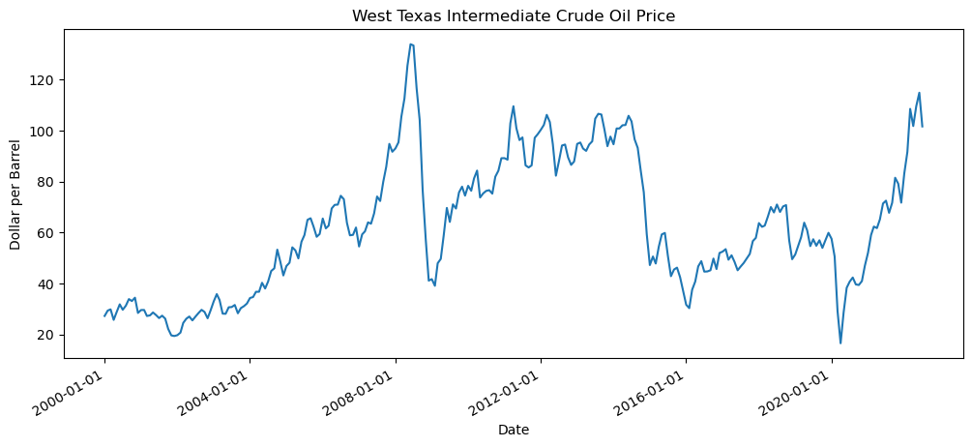

Figure . West Texas Intermediate (WTI) crude oil price

We used Pandas 1.5.2 (McKinney 2011) that is an open-source, simple, powerful, and flexible library for data analysis and data manipulation, Pandas is for Python programming language. The final dataset sized (274, 32) that represent 274-month records (rows) for 32 feature variables (columns).

An important step of data wrangling is dealing with missing data. Table 3 shows the summary statistics of missing data in feature variables. Missingno (Bilogur 2018) is also useful tool that provides a series of visualisations for presence and distribution of the missing data within a pandas dataframe. Figure 2 visually shows the distribution of the missing. To handle the missing data, features with more than the 10% of missing data were dropped from the dataset. The columns that had less than 1% missing features were imputed by using back and forward fill methods. For the remaining missing data between 1% and 10%, the rows for all features were dropped to create a dataset with no missing data. After treating missing data, the final dataframe sized (271, 30).

Table . Summary statistics of missing data in feature variables

|  |  |  |
| --- | --- | --- |
| Variable | Count | Percentage |
| oil_production_world | 3 | 1.1% |
| petroleum_inventory_oecd | 36 | 13.1% |
| global_real_econ_activity_index | 1 | 0.4% |
| us_cpi_energy | 1 | 0.4% |
| eu19_ppi | 2 | 0.7% |
| real_dollar_index | 72 | 26.3% |
| global_econ_policy_uncert_index | 1 | 0.4% |

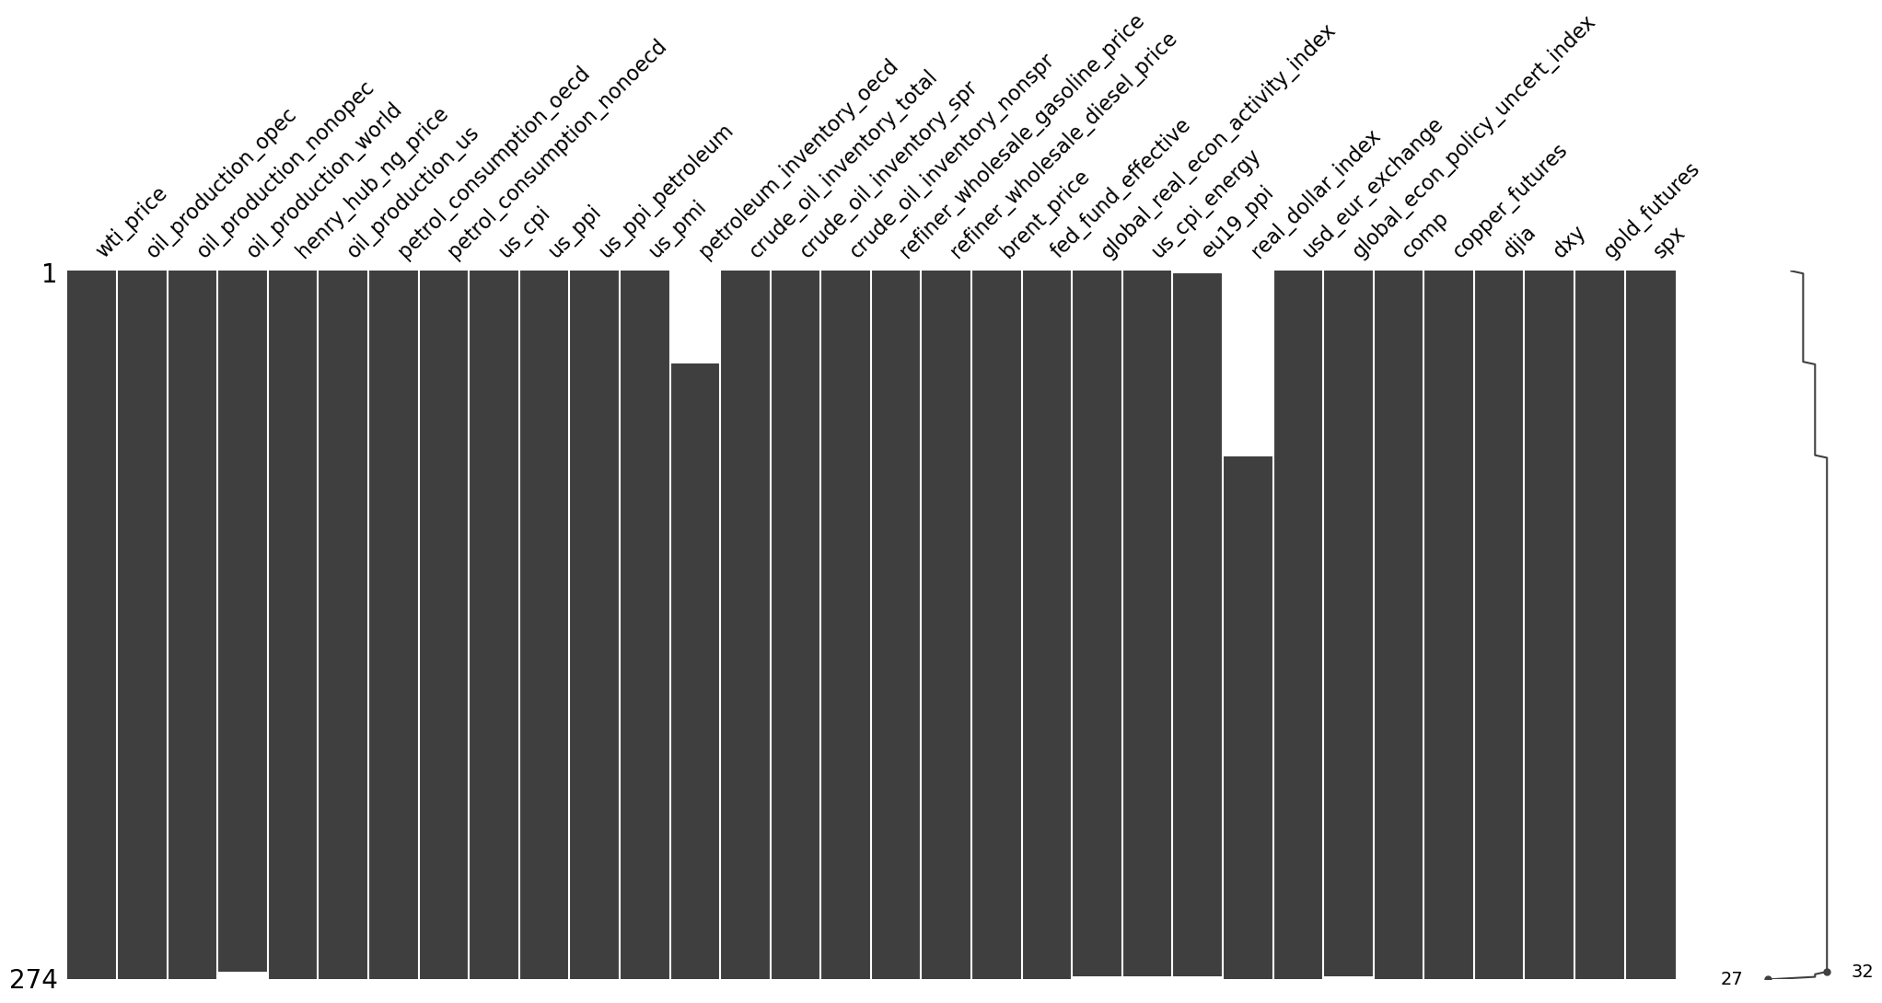

Figure . Missing data plot

## Exploratory Data Analysis and Feature Engineering

WTI-Brent Spread is defined as difference between Brent and the WTI Crude Oil spot prices (Eq. 1). WTI is produced from the Gulf of Mexico basin and is the benchmark for oil price in American market. On the other hand, Brent Oil is produced from the North Sea and Atlantic basin and is the pricing benchmark for European market. While, the prices for these two benchmarks are highly correlated; difference between the prices often reflect technical, supply/demand or geopolitical issues.

|  |  |
| --- | --- |
| WTI-Brent spread = WTI spot price - Brent spot price | (1) |

The Crack spread is defined as the price difference between crude oil and its refined oil (Eq. 2 and 3), reflecting the supply and demand relationship between the crude oil market and its refined product market (Wang, Wu, and Yang 2015).

|  |  |
| --- | --- |
| WTI crack spread = 3 × WTI spot price – 2 × Gasoline Price – 1 × Diesel Fuel Price | (2) |
| Brent crack spread = 3 × Brent spot price – 2 × Gasoline Price – 1 × Diesel Fuel Price | (3) |

After calculating the spreads, Brent price, refiner wholesale gasoline price, and refiner wholesale diesel price were dropped from the dataset.

Figure 3 shows the histograms of initial feature variables and feature engineered variables. Figure 4 includes scatterplots of feature variable against the target variable of WTI oil price. Figure 5 and Figure 6 show the Pearson correlation coefficients matrix, and predictive power score (PPS) matrix for feature variables, respectively.

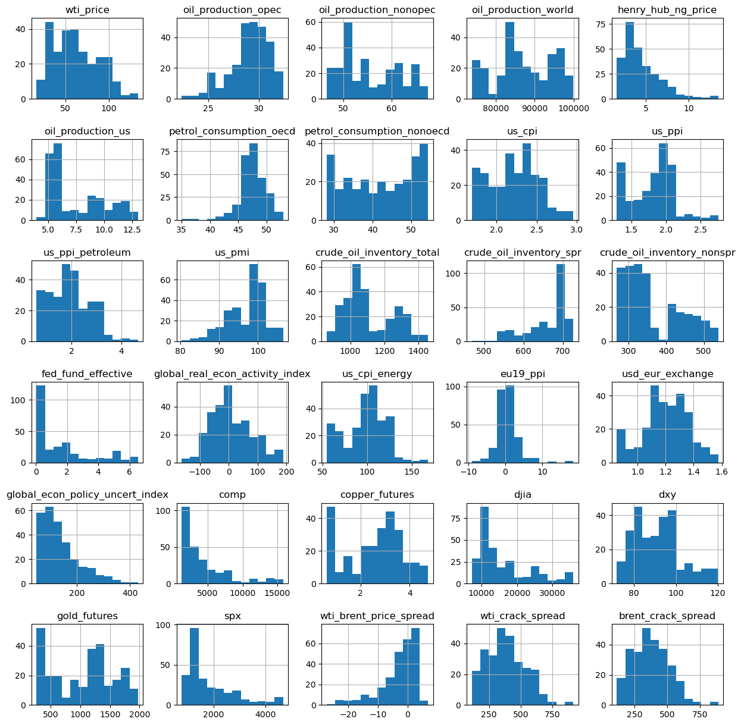

Figure . Histograms of feature variables

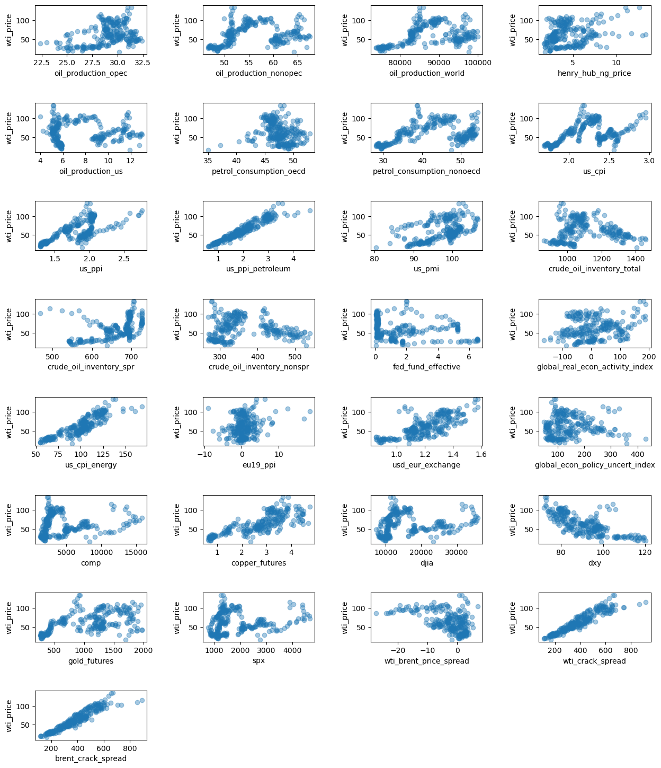

Figure . Scatter plots of feature variable against the target variable

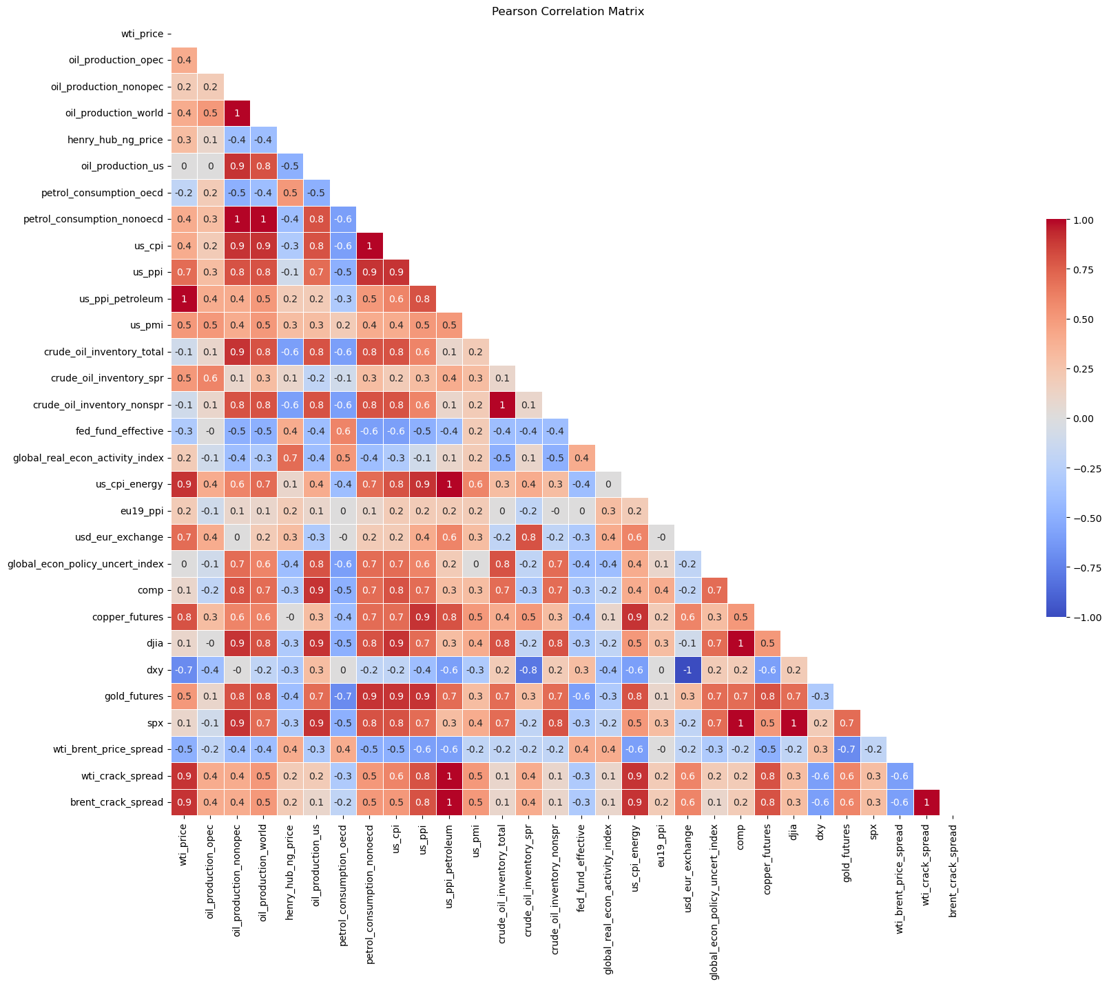

Figure . Pearson correlation coefficients matrix for feature variables

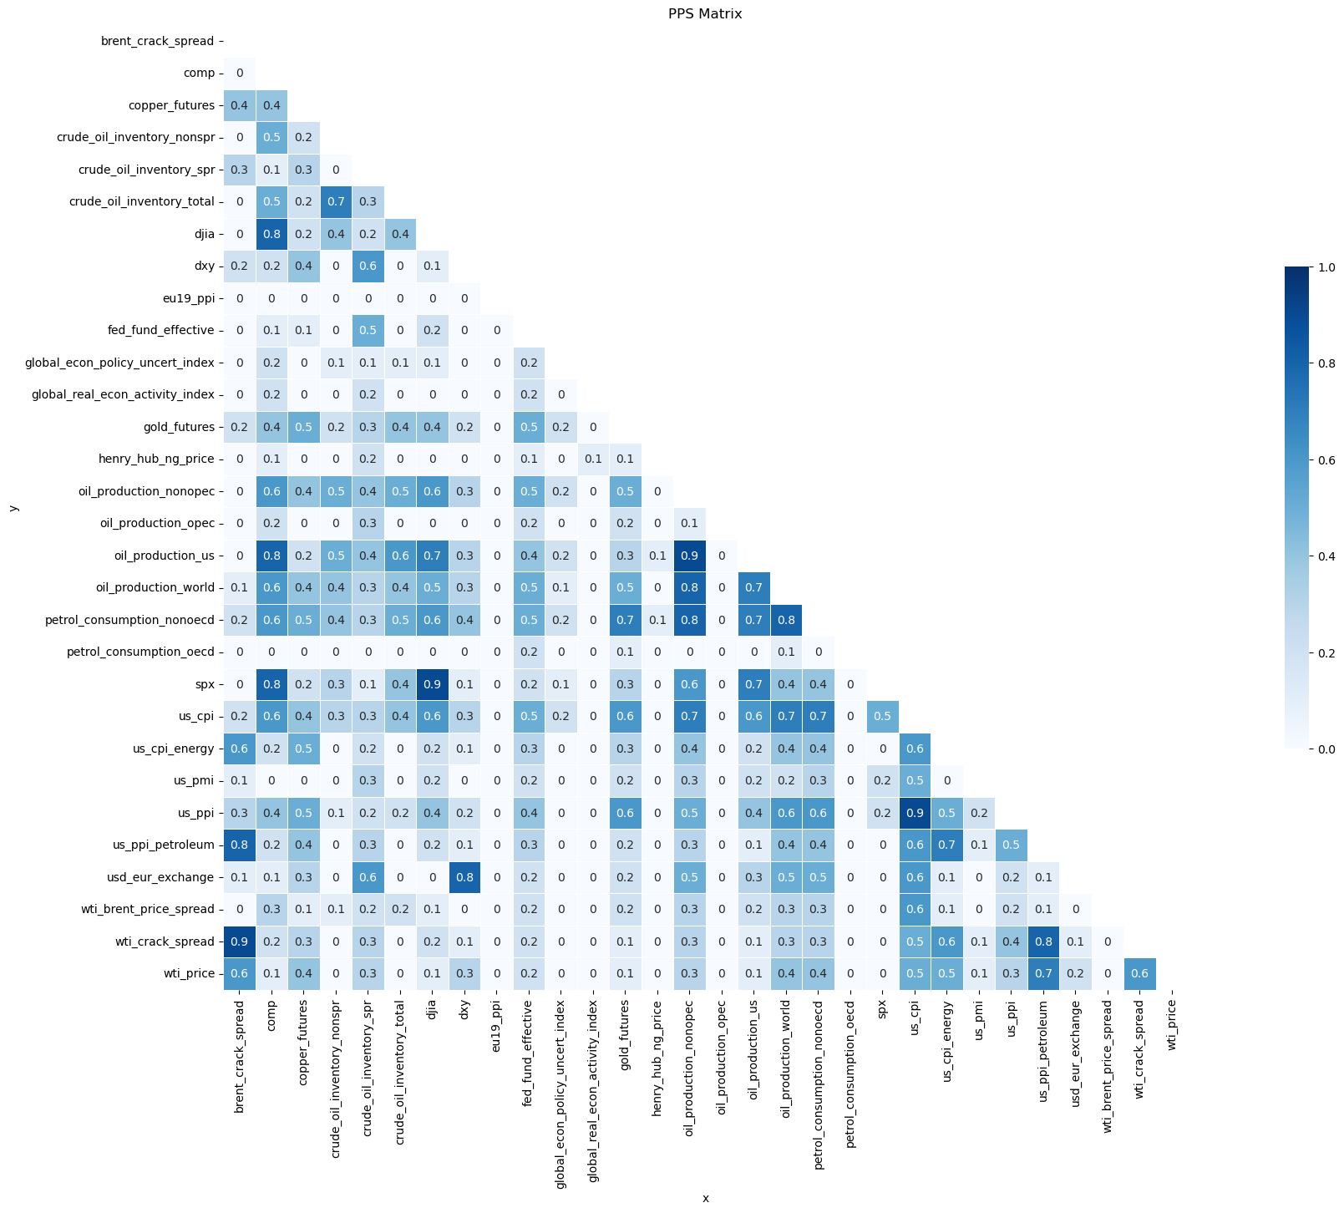

Figure . Predictive Power Score (PPS) matrix for feature variables

## Pre-processing and Training

### Pre-processing

The objective of this time-series analysis is to predict the WTI Price (dependent variable) using the independent variables for a time period in the future, where the independent variables are also unknow. To handle this, a data preparation step is needed before modelling so that the dependent value is shifted in time to be associated with the independent variables of previous time period. The time shift operation is formulated in Eq. 4:

|  |  |
| --- | --- |
|  | (4) |

where is the dependent variable at time , is the independent variable, is the shift operator, is the regression coefficient, and is the residual term.

We performed time shifting for frequency of months. When we shift the dependable variable in time, we end up having rows with missing values. So, it is necessary to handle the missing values by dropping the rows (as described is Sub-section 2.2).

After performing time shifting, the dependent variable will have a new set of independent variables that are specific to that frequency, and in each frequency a different variable may have stronger correlation in the WTI Price. In real world scenario, this can be described and the time-lag for an effect to make an impact on the WTI prices. For example, changes in some features may impact the WTI prices in short term, while some other features may impact the dependent variable in a longer term. With the proposed methodology is expected to capture features with impact frequencies of 1 to 6 months. Figure 7 shows the bar chart of sorted PPS coefficients of independent variables against WTI oil price for 1-to-6-month time shift scenarios.

|  |  |
| --- | --- |
| (a) | (b) |
|  |  |
| (c) | (d) |
|  |  |
| (e) | (f) |

Figure . Bar chart of sorted PPS coefficients of independent variables against WTI oil price multi-frequency time scenarios; a) 1-month, b) 2-month, c) 3-month, d) 4-month, e) 5-month, f) 6-month

Training a model on one dataset and testing it on the same data is a methodological mistake that causes overfitting. The model will learn from the provided sample and adopt to the training data, but it may fail if a different dataset is feed to the model. By partitioning the data into train/test splits, without letting the model to learn about the test split, it is possible to avoid overfitting. Also, the performance of the model can be independency assessed by developing quality metrics based on prediction of the test data (Pedregosa et al. 2011). The train/test split is also critical when optimizing the model estimators by evaluating different settings (“hyper-parameters”) via cross-validation (CV). This approach is also called -fold CV, where the training set is split into smaller sets. Then the model is trained using folds as training data and the resulting model is validated on the remaining part of the data to optimize the model. Finally, the final evaluation is made based on the performance of the unseen test data (Pedregosa et al. 2011; Refaeilzadeh, Tang, and Liu 2009). The train/test split and hyper-parameterization is discussed in training sub-section.

Normalization or scaling of datasets is a commonly required for modelling. As previously presented, the data has various units; however, the variables should be scaled into a common unit. This is usually achieved by removing the mean value of each feature, and dividing the by their standard deviation. It is recommended to find scaling parameters from the train then apply to the test dataset to practically keep them unseen. Figure 8 shows boxplot of scaled train data.

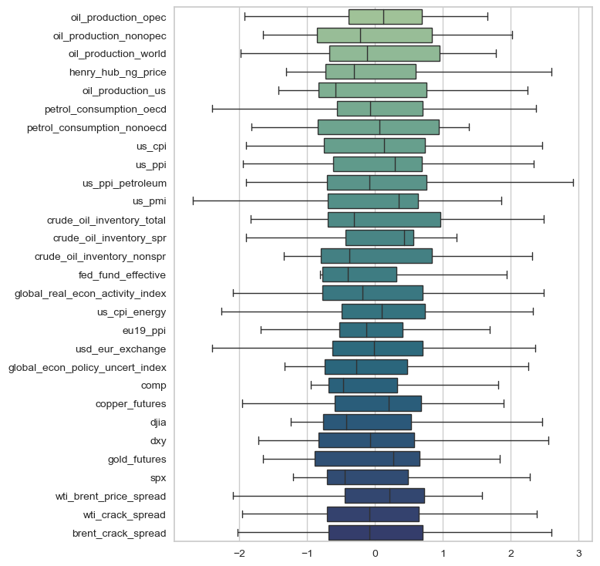

Figure . Boxplots of scaled train datasets

### Training

We use PyCaret, an open-source low code Python library that automates machine learning (AutoML) models to construct and deploy the models (Moez 2022). The library manages twenty-five different algorithms for regression, such as Extra Trees Regressor (ET), Gradient Boosting Regressor (GBR), Extreme Gradient Boosting Regressor (XGB), Random Forest Regressor (RF), Linear Regression (LR), AdaBoost Regressor (ADA), and eighteen other algorithms for classification. We compare the performance of twenty-five AutoML models based on coefficient of determination (R2), Mean Absolute Error (MAE), Mean Squared Error (MSE), and Root Mean Squared Error (RMSE). (Ardabili, Mosavi, and Várkonyi-Kóczy 2020).

PyCaret offer settings for train/test splits, missing value imputation methods, scaling, normalziation, etc. Table 4 shows the Pycaret regression session settings, where the data is configured to train/test split by 70/30, and transformation and normalization to be applied.

Table . PyCaret regression session settings

|  |  |
| --- | --- |
| Description | Value |
| Session id | 786 |
| Target | wti_price |
| Target type | Regression |
| Data shape | (270, 30) |
| Train data shape | (188, 30) |
| Test data shape | (82, 30) |
| Numeric features | 29 |
| Preprocess | True |
| Imputation type | simple |
| Numeric imputation | mean |
| Categorical imputation | constant |
| Low variance threshold | 0 |
| Transformation | True |
| Transformation method | yeo-johnson |
| Normalize | True |
| Normalize method | zscore |
| Fold Generator | KFold |
| Fold Number | 10 |

After setting the PyCaret session, preformed the initial modeling on multiple time frequencies. For each scenario we compared the performance of ML models with 5-fold of cross-validation generator and stored the top 5 best performance models to be later used to build ensemble models. Table 5 shows the performance of ML models on the predicting WTI price for 1-month frequency scenario.

Table . Performance of ML models for 1-month frequency scenario

|  |  |  |  |  |  |  |  |
| --- | --- | --- | --- | --- | --- | --- | --- |
|  | Model | MAE | MSE | RMSE | R2 | RMSLE | MAPE |
| et | Extra Trees Regressor | 4.51 | 40.47 | 6.32 | 0.95 | 0.12 | 0.08 |
| gbr | Gradient Boosting Regressor | 5.10 | 48.24 | 6.85 | 0.94 | 0.12 | 0.09 |
| lightgbm | Light Gradient Boosting Machine | 5.22 | 53.37 | 7.25 | 0.93 | 0.12 | 0.09 |
| rf | Random Forest Regressor | 5.30 | 55.06 | 7.38 | 0.93 | 0.13 | 0.10 |
| lr | Linear Regression | 5.90 | 56.68 | 7.49 | 0.93 | 0.16 | 0.12 |
| ada | AdaBoost Regressor | 5.80 | 59.57 | 7.63 | 0.92 | 0.13 | 0.11 |
| huber | Huber Regressor | 5.81 | 58.89 | 7.64 | 0.92 | 0.16 | 0.12 |
| ridge | Ridge Regression | 5.94 | 59.68 | 7.69 | 0.92 | 0.16 | 0.12 |
| br | Bayesian Ridge | 6.02 | 62.60 | 7.88 | 0.92 | 0.16 | 0.12 |
| lasso | Lasso Regression | 6.26 | 68.05 | 8.22 | 0.91 | 0.16 | 0.12 |
| knn | K Neighbors Regressor | 5.89 | 73.74 | 8.42 | 0.90 | 0.14 | 0.11 |
| omp | Orthogonal Matching Pursuit | 6.31 | 75.90 | 8.70 | 0.90 | 0.17 | 0.12 |
| en | Elastic Net | 6.86 | 79.07 | 8.86 | 0.89 | 0.17 | 0.13 |
| dt | Decision Tree Regressor | 6.64 | 84.37 | 9.07 | 0.88 | 0.15 | 0.12 |
| par | Passive Aggressive Regressor | 8.66 | 132.63 | 10.90 | 0.82 | 0.31 | 0.19 |
| llar | Lasso Least Angle Regression | 12.88 | 249.70 | 15.76 | 0.67 | 0.28 | 0.26 |
| dummy | Dummy Regressor | 23.21 | 756.93 | 27.45 | -0.01 | 0.48 | 0.50 |

Then, we performed hyper-parameterization by dynamically optimizing the top 5 models based on RMSE value through 120 iterations with 5-fold CV (totaling 600 fits). Next, we select the optmized top five models for each time-frequency and build ensemble models. Ensemble methods benefit different training algorithms for increasing the training accuracy for reaching a higher testing accuracy to substantially improve the accuracy of the integerated model (Ardabili, Mosavi, and Várkonyi-Kóczy 2020). The most common ensemble methods are votting regressor and stacking regressor. Votting regressor uses a majority vote to build consensus of final prediction values. Stacking uses meta learning to create multiple base estimators to generate the final prediction (An and Meng 2010; Džeroski and Ženko 2004).

Figure 9 shows voting and stacking regression ensemble model of the top 5 ML models, and Table 6 summarizes the performance metrics on test datasets of the ensemble models for 1-month frequency WTI price prediction.

|  |
| --- |
|  |
| (a) |
|  |
| (b) |

Figure . Ensemble models of top 5 ML models for 1-month frequency scenario; a) voting regressor, and b) stacking regressor

After comparing the performance of the ensemble model on test datasets, the best model was stored and the final model for that scenario. Table 6 and Figure 10 show side-by-side performance evaluation for voting and stacking regressor of 1-month scenario, where stacking regressor was found to have better performance in this case.

Table . Performance metrics on test datasets for voting and stacking regressor on 1-month frequency scenario

|  |  |  |  |  |  |  |  |
| --- | --- | --- | --- | --- | --- | --- | --- |
| Ensemble model | Metric | MAE | MSE | RMSE | R2 | RMSLE | MAPE |
| Votting Regressor | Mean | 4.5984 | 38.9276 | 6.1874 | 0.9486 | 0.1129 | 0.0865 |
| Std | 0.5388 | 10.0889 | 0.8024 | 0.01 | 0.0343 | 0.0234 |
| Stacking Regressor | Mean | 4.5974 | 39.7895 | 6.1574 | 0.9475 | 0.1106 | 0.0848 |
| Std | 0.8137 | 17.5949 | 1.3699 | 0.0212 | 0.041 | 0.0281 |

|  |  |
| --- | --- |
| (a) | (b) |
|  |  |
| (c) | (d) |
|  |  |
| (e) | (f) |

Figure . Size-by-side evaluation of ensemble model performances of 1-month frequency scenario; a) residuals for voting regressor, b) residuals for stacking regressor, c) prediction error for voting regressor, d) prediction error for stacking regressor, e) learning curve for voting regressor, and d) learning curve for stacking regressor

The aforementioned steps on training, optimization, ensemble modeling was performed for 1- to 6-month time frequency scenario and the best performance model and it performance metrics stored for final modeling.

## Modelling

Table 7 shows the final selected ensemble models for the 6 frequency scenarios, where voting regressor was used to build the 2- and 4-month frequncies and stacking regressor was used for the other four scenarios. For the final models, the performances were analyzed on the entire dataset including both test and train sets to calculate the performance metrics (Table 7).

Table . Performance of final models on entire dataset

|  |  |  |  |  |  |  |  |
| --- | --- | --- | --- | --- | --- | --- | --- |
| Model | Ensemble | MAE | MSE | RMSE | R2 | RMSLE | MAPE |
| 1-month | Stacking Regressor | 0.9828 | 1.9863 | 1.4094 | 0.9971 | 0.0246 | 0.0164 |
| 2-month | Voting Regressor | 1.4974 | 4.0136 | 2.0034 | 0.9941 | 0.0385 | 0.0273 |
| 3-month | Stacking Regressor | 1.3449 | 4.1664 | 2.0412 | 0.9938 | 0.0344 | 0.0224 |
| 4-month | Voting Regressor | 1.8882 | 6.3462 | 2.5192 | 0.9905 | 0.0503 | 0.0346 |
| 5-month | Stacking Regressor | 1.2967 | 5.0315 | 2.2431 | 0.9925 | 0.0553 | 0.025 |
| 6-month | Stacking Regressor | 1.2893 | 5.3536 | 2.3138 | 0.9920 | 0.0585 | 0.0253 |

|  |  |
| --- | --- |
| (a) | |
| (b) | (c) |

Figure .

### Extend Date index for predicted months

### Cast predictions to the dataframe

## Plot predictions

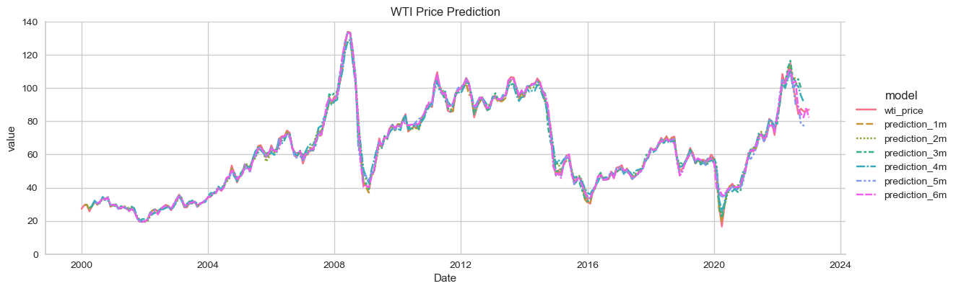

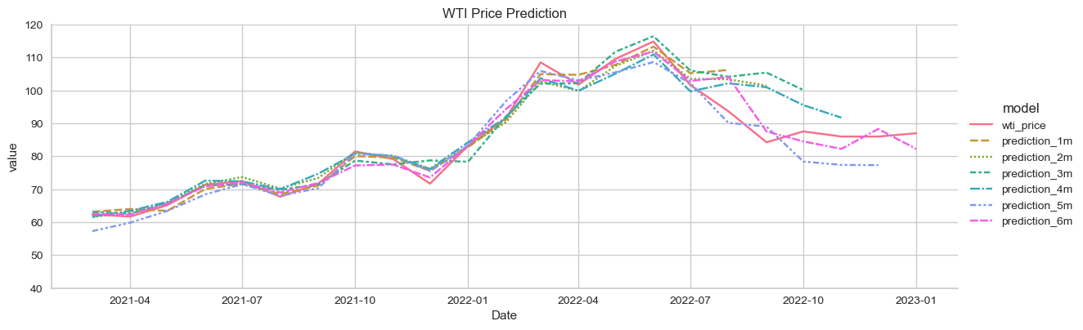

## Calculate Expected Average

#Make a copy to store average predictions

df_average = dates_extend_df.copy()

### Calculate weights

#Calcluate weight as 1/RMSE

weights = power(rmse_all, -1)

#Calclate weighted mean of predictions

df_average['avg_prediction'] = (df_average.iloc[:,3:]*weights_df).sum(axis=1)

### Calcalte average RMSE and upper and lower bounds

2.5758 is used because the 99% confidence interval has only 1% on each side. The probability for a z score below −2.5758 is 1%, and similarly for a z score above +1.96; added together this is 1%.

#Calcluate average RMSE of multiple models

count_rmse = dates_extend_df.notnull().iloc[:,3:].sum(axis=1)

df_average['avg_rmse'] = np.sqrt(sum(power(rmse_all,2))/count_rmse)

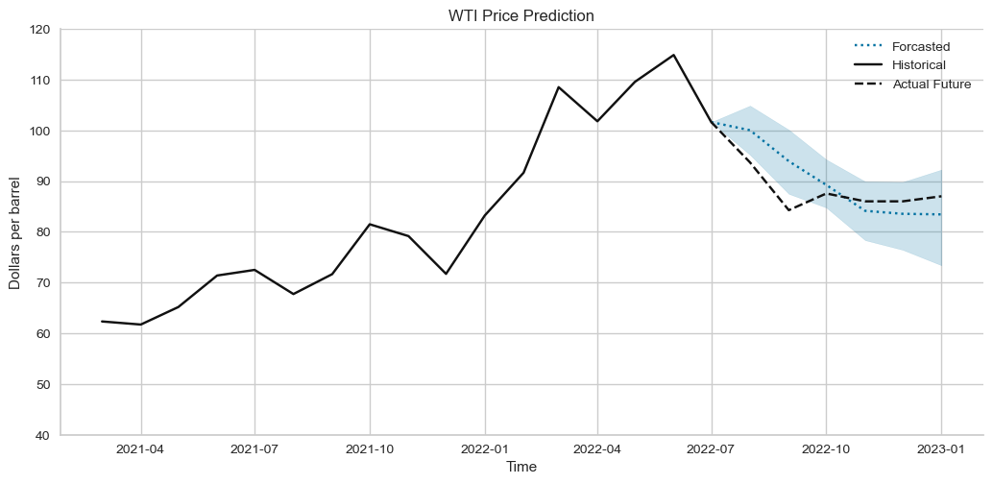

# Results and Discussion

# Recommendations and Future Work

* Fused TIR and RGB 3D models generated from UAS imagery offer great potential for mapping heat loss, supplementing non-destructive testing of structures, aiding in the inspection of electrical parts, and more.
* This study tested a simplified approach for generating 3D TIR point clouds from coacquired TIR and RGB images for remote sensing applications. The constructed TIR point clouds are georeferenced to the same coordinate system as the RGB clouds. The resultant point cloud preserves the spatial density and resolution of the RGB point cloud while adding TIR attributes.
* The integrated visualization approach tested in this study enables 3D point cloud and 2D raster representation of RGB and TIR data in one model, enhancing the visual interpretation and analysis of the remotely-sensed data.
* The approach does not require additional depth sensors, such as lidar, or GNSS-aided INS for registration purposes.
* In general, the approach is appropriate for cases when….. For evaluation, and as examples of implementation…. While the SfM processing of RGB images was able to generate reliable….
* In future work, the proposed integration and visualization can be integrated into standard …... Radiometric calibration was considered beyond the scope of the present study; however, in-situ radiometric calibration of the thermal camera might improve the spectral content of the data. As an alternative …...
* TIR-RGB image feature matching and auto-registration can handle non-synchronized dual-head camera captures; however, extraction of identical features and co-registration based on the extracted pair is challenging for images of different spectral bands at the scene without well-designed calibration patterns.
* It is recommended that follow-on studies be conducted to address these topics…..

# Acknowledgments

We thank … for their valuable comments and suggestions on improving the quality of this paper.

We are thankful to …. for their help with collecting the data,

We would like to acknowledge … for supplying the logistics for

We also appreciate …. for providing surveying equipment and/or software.

We would like to thank …. anonymous reviewers for their constructive suggestions and comments.

# References

An, Kun, and Jiang Meng. 2010. “Voting-Averaged Combination Method for Regressor Ensemble.” In *International Conference on Intelligent Computing*, 540–546.

Ardabili, Sina, Amir Mosavi, and Annamária R. Várkonyi-Kóczy. 2020. “Advances in Machine Learning Modeling Reviewing Hybrid and Ensemble Methods.” In , 215–227. doi:10.1007/978-3-030-36841-8_21.

Basiri, Mohammad Hossein; Javadnejad, Farshid; Saeedi, Azita. 2015. “Forecasting Crude Oil Price with an Artificial Neural Network Model Based on a Regular Pattern for Selecting of the Training and Testing Sets Using Dynamic Command-Line Functions.” In *24th International Mining Congress and Exhibition of Turkey-IMCET’15*.

Bilogur, Aleksey. 2018. “Missingno: A Missing Data Visualization Suite.” *The Journal of Open Source Software* 3 (22). The Open Journal: 547. doi:10.21105/JOSS.00547.

Deng, Chao, Liang Ma, and Taishan Zeng. 2021. “Crude Oil Price Forecast Based on Deep Transfer Learning: Shanghai Crude Oil as an Example.” *Sustainability* 13 (24): 13770. doi:10.3390/su132413770.

Džeroski, Saso, and Bernard Ženko. 2004. “Is Combining Classifiers with Stacking Better than Selecting the Best One?” *Machine Learning* 54 (3). Springer: 255–273.

EIA. 2022a. “Opendata - U.S. Energy Information Administration (EIA).” https://www.eia.gov/opendata/.

EIA. 2022b. “International Energy Statistics, Total Oil Production.” *U.S. Energy Information Administration*.

FRED. 2022. “St. Louis Fed Web Services: FRED® API.” https://fred.stlouisfed.org/docs/api/fred/.

Hamilton, James. 2008. *Understanding Crude Oil Prices*. Cambridge, MA. doi:10.3386/w14492.

Hamilton, James. 2009. *Causes and Consequences of the Oil Shock of 2007-08*. Cambridge, MA. doi:10.3386/w15002.

Hou, Aijun, and Sandy Suardi. 2012. “A Nonparametric GARCH Model of Crude Oil Price Return Volatility.” *Energy Economics* 34 (2): 618–626. doi:10.1016/j.eneco.2011.08.004.

Investing. 2022. “Investing.Com - Stock Market Quotes & Financial News.” https://www.investing.com/.

Jammazi, Rania, and Chaker Aloui. 2012. “Crude Oil Price Forecasting: Experimental Evidence from Wavelet Decomposition and Neural Network Modeling.” *Energy Economics* 34 (3): 828–841. doi:10.1016/j.eneco.2011.07.018.

Javadnejad, Farshid. 2012. “Presenting a Model for Prediction of Crude Oil Price Based on Artificial Intelligent Hybrid Methods and Time-Series.” Tarbiat Modares University.

Kilian, Lutz, and Daniel P. Murphy. 2014. “THE ROLE OF INVENTORIES AND SPECULATIVE TRADING IN THE GLOBAL MARKET FOR CRUDE OIL.” *Journal of Applied Econometrics* 29 (3): 454–478. doi:10.1002/jae.2322.

Kluyver, Thomas, Benjamin Ragan-Kelley, Fernando Pérez, Brian E Granger, Matthias Bussonnier, Jonathan Frederic, Kyle Kelley, et al. 2016. *Jupyter Notebooks: A Publishing Format for Reproducible Computational Workflows.* Vol. 2016. https://jupyter.org/.

Lanza, Alessandro, Matteo Manera, and Massimo Giovannini. 2005. “Modeling and Forecasting Cointegrated Relationships among Heavy Oil and Product Prices.” *Energy Economics* 27 (6): 831–848. doi:10.1016/j.eneco.2005.07.001.

Lu, Quanying, Shaolong Sun, Hongbo Duan, and Shouyang Wang. 2021. “Analysis and Forecasting of Crude Oil Price Based on the Variable Selection-LSTM Integrated Model.” *Energy Informatics* 4 (S2): 47. doi:10.1186/s42162-021-00166-4.

McKinney, Wes. 2011. “Pandas: A Foundational Python Library for Data Analysis and Statistics.” *Python for High Performance and Scientific Computing* 14 (9). Seattle: 1–9. https://pandas.pydata.org/.

Moez, Ali. 2022. “PyCaret: An Open Source, Low-Code Machine Learning Library in Python.”

Murat, Atilim, and Ekin Tokat. 2009. “Forecasting Oil Price Movements with Crack Spread Futures.” *Energy Economics* 31 (1): 85–90. doi:10.1016/j.eneco.2008.07.008.

Pedregosa, F, G Varoquaux, A Gramfort, B Michel V.  and Thirion, O Grisel, M Blondel, R Prettenhofer P.  and Weiss, et al. 2011. “Scikit-Learn: Machine Learning in Python.” *Journal of Machine Learning Research* 12: 2825–2830.

Python Software Foundation. 2022. “Python.” Python Software Foundation (PSF). https://www.python.org/.

Refaeilzadeh, Payam, Lei Tang, and Huan Liu. 2009. “Cross-Validation.” *Encyclopedia of Database Systems* 5. Springer: 532–538.

Wang, Yudong, Chongfeng Wu, and Li Yang. 2015. “Forecasting the Real Prices of Crude Oil: A Dynamic Model Averaging Approach.” *SSRN Electronic Journal*. doi:10.2139/ssrn.2590195.

WSJ. 2022. “The Wall Street Journal - Breaking News, Business, Financial & Economic News, World News and Video.” https://www.wsj.com/.

Yu, Lean, Yang Zhao, and Ling Tang. 2017. “Ensemble Forecasting for Complex Time Series Using Sparse Representation and Neural Networks.” *Journal of Forecasting* 36 (2): 122–138. doi:10.1002/for.2418.

Zhao, Yang, Jianping Li, and Lean Yu. 2017. “A Deep Learning Ensemble Approach for Crude Oil Price Forecasting.” *Energy Economics* 66 (August): 9–16. doi:10.1016/j.eneco.2017.05.023.